## How to change project java version

to change project java version--> right click project--> open module setting->proj🡪 set language level

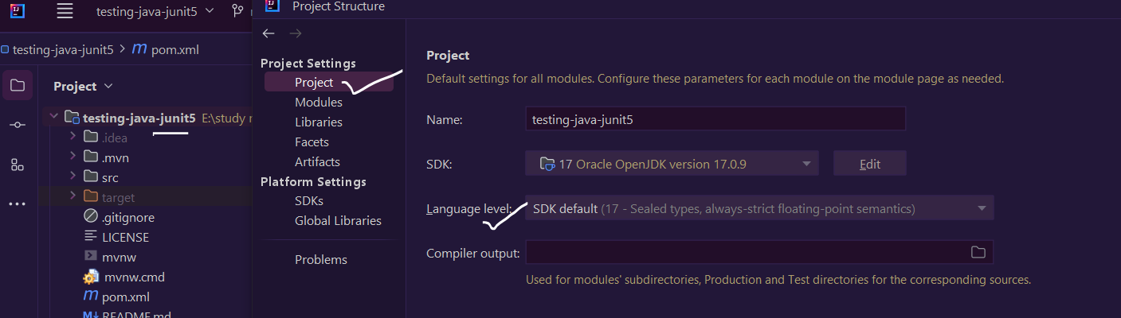

Enable annotation processing

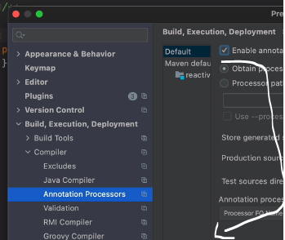

## Intellij shortcuts

C- Control

1. ALT

|  |  |
| --- | --- |
| Extract local variable | Ctrl+ ALT +V |
| Extract a method | Ctrl+ Alt +M |
| Surround with try – catch /if-else … | Ctrl + ALT+T |
| To create an empty line at current cursor & existing line will be pushed down | Ctrl+Alt+Enter |
| Show usages | C +A+F7 |
| To open project tool window | A+1 |
| Auto complete | C+shift+Enter |
| Ctrl+w | To close the current window |
|  |  |